When selecting a VO_{2MAX} protocol, it is important to understand several things:
- Equipment needed vs equipment available: treadmill, heart rate monitor, step, metronome, etc.
- Your client:
  - Risk stratification or mobility issues: knee problems? use a bike instead of a step; on blood pressure medication? do a submaximal versus a maximal test protocol
  - Exercise habits/experience: if your client is an avid runner, you wouldn’t use a cycle ergometer or step test protocol, you’d use a treadmill
  - Weight: an overweight individual may have stability problems, thus a step test or treadmill test may not be appropriate
  - Age: same for an older adult with mobility/stability problems
Before starting any test, be sure you have taken:
- Medical health history and Risk Stratification
- Resting heart rate and blood pressure
- Clients age, height, weight, sex
Protocol:
- Equipment needed:
  - jogging track
  - stop watch
- Instruct your client to complete 1.5 miles as fast as possible.
- Record their finishing time.
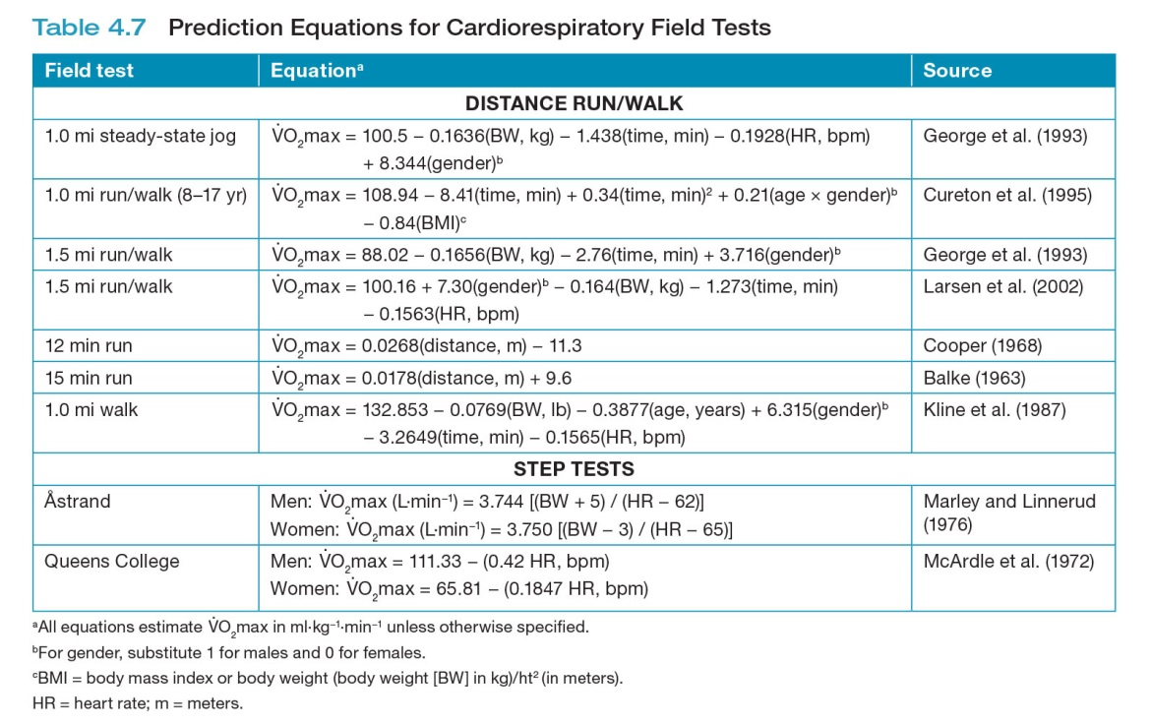
- Perform the calculation below.

