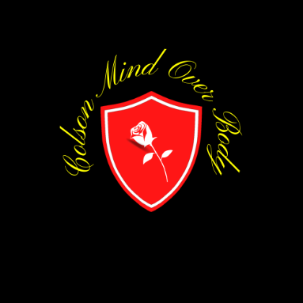
Erik Colson: Full-consent form

Dear potential client:

You are being asked to serve as a client for __________________________ This program involves participating in lifestyle assessment, health and fitness testing, and behavioral analysis activities designed to allow the essential tasks that a Certified Exercise Physiologist would perform. Each client is asked to take part in a series of meetings with the Exercise Physiologist over the course of four months. The prescribed program is based upon the results of the following assessment:
- Preparticipation screening: health history questionnaire, exercise pre-participation health screening questionnaire, and the physical activity readiness questionnaire (PARQ+ 2021).
- Anthopometrics: self-reported age, biological sex, gender, height, weight
- Baseline fitness + muscular endurance testing: a field VO2MAX test, a plank test, and a push- up test
- Dietary and physical activity analysis: record minimum 5-days of food/fluids as well as all physical activity and exercise for analysis
- Behavior analysis: a series of meetings regarding feelings about physical activity/exercise, barriers/limitations, goal-setting, and motivational interviewing

Should you have any questions, please notify me. Thank you for your time.
Sincerely,

Erik Colson
Godfather of Colson Mind Over Body
Director of Pilates Spring Park, Minnesota
State University , NHCC, and NCC ExSci Partnership Program Colson.m.o.b@gmail.com – 763.486.8274

I have read the above information and give my full-consent to participate as a client for ______________________

Participant’s Signature ___________________________ Date:

Participant’s Printed Name & Phone/email

Employee Signature Date:

Employee Printed Name & Phone/email

Colson Mind Over Body Exercise Science Program: Consent is as easy as F.R.I.E.S.

